Booking Form

Full names and ages of all party members:

Address:

Email address:

Telephone Number:

If you will be travelling with a mobile please let us know the number:

I wish to let the property from (dates): to:

BEDROOM DETAILS

Please see floorplan diagram below of the bedrooms. Please mark clearly each bed required with an X (on the actual beds, so the caretakers know how many beds to make up). There is a £20 charge per bed to include towels for 2 people per double bed. Please add to total cost. A £0.90 per person per night (over 18’s only) for tourist tax in addition.

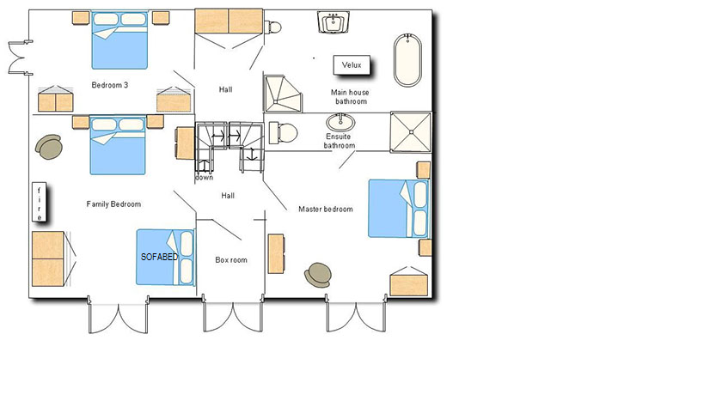

If you require a mid-stay linen change this can be arranged in advance and is chargeable at £15 per bed. Please add this amount to the total cost of your holiday and tick yes or no below if required.

Mid stay linen change required? £20 per double bed yes……….no……..

The total price for the duration of my holiday including a £200 returnable damages deposit (see Terms of Use), linen + towel charge at £20 per double bed (bedding and towels for 2 people) plus mid stay linen change (if applicable) is: £

Deposit paid (25% of total cost including £200 returnable damages deposit (See terms of use) plus appropriate linen charges - is:
£ and the balance is:
£ due on (date - 8 weeks prior to commencement of holiday): / /

Please return this completed and signed booking form and any cheques to the following address:

23 Grangefield Avenue
Burley in Wharfedale
Ilkley
West Yorkshire
LS29 7HA

Please make cheques payable to Mr Tim Cookson or Mrs Lucy Cookson.

Payments can also be made by bank transfer. Our account details can be supplied upon request. Please note however that the signed booking form will still be required by post.

If you would like your damage deposit to be returned to you (where applicable – see Terms of Use) by bank transfer rather than by cheque please supply the following information:

Sort code: Account number: Account name:

Please can you tell us where you saw our advert and what in particular it was that influenced your choice?

Official Use Only
Client directed to Visitor Info Page: Caretakers informed: Confirmation sent:
Date deposit received: Balance due:

Cheque number: Account Number: Sort Code:

Availability updated:

*******************************************************************
Terms of Use

I agree to rent this property as a furnished holiday home only and will make no commercial gain from the rental of it.

Parents or guardians are strictly responsible for all children and pets. The owners accept no responsibility or liability for any injuries incurred to any member of the visiting party on the entire premises. Any injuries incurred on bicycles or any of the other facilities provided are not the responsibility of the owners and the owners accept no liability.

The tenant has paid a £200 damage deposit, which is only returnable on satisfactory inspection of the property after departure. Damages and breakages are chargeable at the discretion of the owners. In the event that the owners are not present for the inspection of the property this will be carried out by the nominated caretaker(s). The caretaker(s) will inform the owners of any damages/breakages found. The owners undertake to forward any remaining balance of the damage deposit by cheque to the tenant’s home address as soon as possible. There will be no charges if the property is found to be without any defects. If the property is found to require excessive cleaning (i.e. more than would be considered normal for the period of your stay) then a charge may have to be made in order to pay for additional cleaning. The management reserves the right to cancel the returned £200 damages cheque (in very extreme cases) if it is found that some damages were undetected on inspection and were found after you have left the property.

Please keep children away from the windows and ensure that they are shut whenever possible so that they cannot fall out, particularly if left unattended. The well in the front garden of the main house has a large stone on top of the lid in order to stop its removal. Please note that this has been done in the interests of child safety, therefore, please do not remove the stone or the lid from the well.

Please take care not to allow your children or pets to run out onto the road.

Please do not put anything down the toilet other than French toilet tissue and human waste. Cotton buds, cigarette butts, sanitary products etc could block the septic tank. Should the septic tank block, in extreme cases there could be a 300 euro charge for the call out if it is found to be the fault of the tenant.

Please ensure that all windows and doors are locked when the property is unoccupied. Please shut downstairs shutters and lock all doors when you are asleep.

Please be considerate of our neighbours.

Please do not leave the wood burner door open when lit and do not leave any open fires unattended when lit. Wood burner and/or open fires are only to be used with the prior consent of the owners.

Please do not remove the protective cover or tablecloth from the dining room table.

Please do not leave children unattended in the property at any time.
Terms of Use

Please do not leave children unattended with the cooker, heaters, wood burner or open fires.

The lawned area to the front of Petit Logis (cottage) MUST NOT be driven on or parked on, as there are filtration pipes underneath that could be crushed by a car/van/lorry.

Please note: it is advisable to take out holiday insurance to cover cancellations of your holiday rental for any reason.

If you (the client) wish to cancel your booking please let the Owners know as soon as possible. Any deposits are non-refundable.

Please see below for sliding scale of refund percentages in the event of cancellation of the holiday rental by you (the client).

No. of wks before commencement of holiday rental

10 weeks: 90% refund of monies paid (less non refundable deposit)
8 weeks: 80% refund of monies paid (less non refundable deposit)
6 weeks: 60% refund of monies paid (less non refundable deposit)
4 weeks – 2 weeks: 10% refund of monies paid (less non refundable deposit)
Less than 2 weeks: No refund.

For any loss, damage or inconvenience caused to or suffered by you (the client) due to cancellation of your holiday rental by the Owners for any reason, the Owners shall notify you (the client) and refund to you (the client) all sums previously paid in respect of the holiday rental. Under no circumstances shall the Owners’ liability to you (the client) exceed the amount paid to the Owners for the holiday rental period.

The Owners shall not be liable for any changes made by flight/rail/ferry companies to travel times or for any cancellations made by said companies.

The Owners shall not be liable to you (the client) if they cannot carry out their obligations to provide you (the client) with the rental property for your booked holiday period due to any of the following:

• Political disputes or Force Majeure.
• Any malicious or wilful action, negligence, misuse or third party interference.
• Any defect or damage occasioned by fire, lightening, explosion, flood, storm, tempest, impact or any other extraneous cause.
• Any defect or damage occurring from the failure of the public electricity, gas, water supply or roads.

The Owners shall not be liable to you (the client) in the event of:

• Any defect or stoppage in the supply of public services to the property nor in respect of any equipment, machinery or appliances in the property, gardens or swimming pool.
• Any loss, damage or injury which is the result of adverse weather conditions, riot, war, strikes or any other matters beyond the control of the Owners.
• Any loss, damage or inconvenience caused to or suffered by you (the client) if the property is destroyed or substantially damaged before the start of the holiday rental period.

The Owners shall not be responsible for any failure out of their direct control.
Terms of Use

Refunds or compensation shall be made at the sole discretion of the Owners.

The Owners reserve the right to change specifications without notice.

POOL DISCLAIMER

FOR SAFETY REASONS WE ASK THAT THERE IS NO DIVING OR RUNNING AROUND THE POOL AND THAT CHILDREN ARE ACCOMPANIED AT ALL TIMES.

PLEASE DO NOT BRING ANY GLASS INTO THE POOL AREA OR ANYTHING ELSE THAT COULD TEAR THE LINER.

PLEASE ENSURE THE POOL GATE IS KEPT CLOSED AND LOCKED AT ALL TIMES.

THE SUMMER COVER SHOULD BE ON THE POOL WHEN NOT IN USE, ESPECIALLY AT NIGHT.

SWIMMING AND BATHING IS ENTIRELY AT YOUR OWN RISK. IN CASE OF AN ACCIDENT THE MANAGEMENT ACCEPTS NO RESPONSIBILITY OR LIABILITY.

I hereby sign to say that I will abide by the above conditions whilst renting Maison du Puits, 13 Rue Des Allées, 17330, Villeneuve La Comtesse, Charente Maritime, France.

Sign:

Print name:

Date:

OWNER AND CARETAKER DETAILS
OWNERS TIM AND LUCY COOKSON 07747 621104 0R 01943 863498
CARETAKERS KATH AND STEVE 0033 546322590

